*Target Practice*

**About The Game:**

It’s a small football related game. A football lover always wants to score. The main purpose of the game is to shoot in perfect time and location. A target is moving on the goal-post. A goal contains 100 points. If you can shoot the target you will get 300 points as a bonus. Totally you can hit 5 times on the ball. The total points will be your score. If your point is equal to high score then it will be the high score for the game. You can also reset the high score. So hitting on the target is the main purpose of the game. I hope it will be enjoyable.

*Project : Target Practice-Steps*

1.design the field & the ball.

2.add goal post & net in the post.

3.add a target on the goal-line.

5.necessary code to add a marker on the moving-direction of the ball

4.necessary program to control the ball.

6.necessary code to move the target.(motion with the ball)

7.necessary code to count the point & at the end of shooting count the total score & show the result of the game.

***Creating Project On Unity:***

***Open unity-> New-> Name->Memory Location->2D/3D.***

***Then save it.***  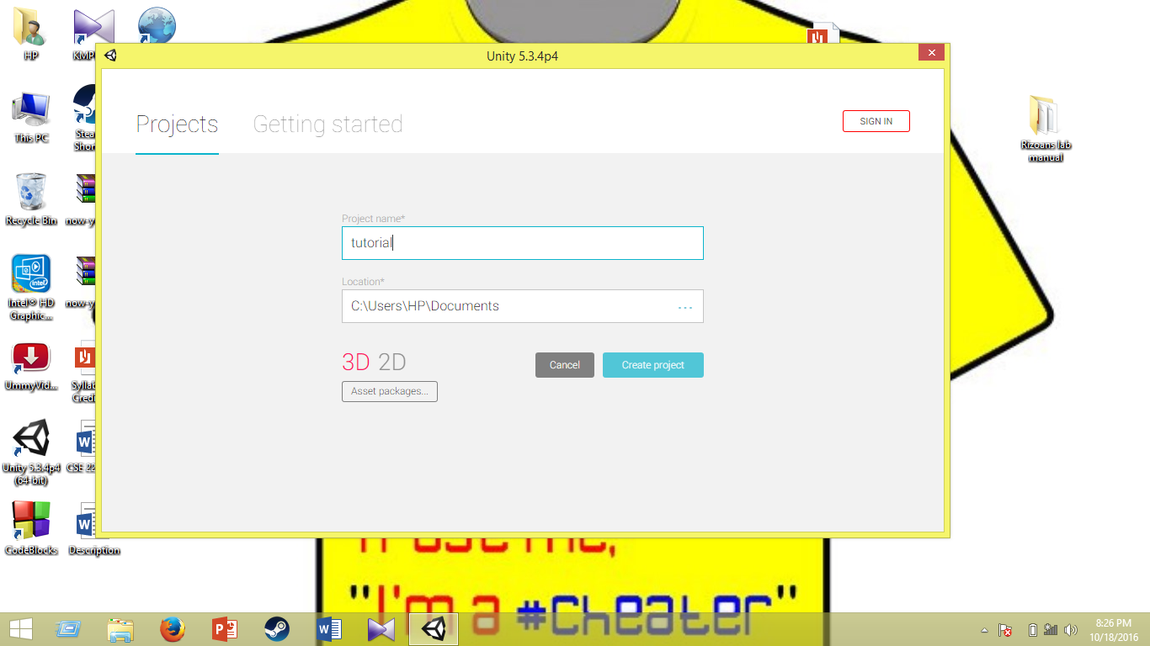

***Creating game Objects***

***#Add Light:***

***Create->light->directional light.***

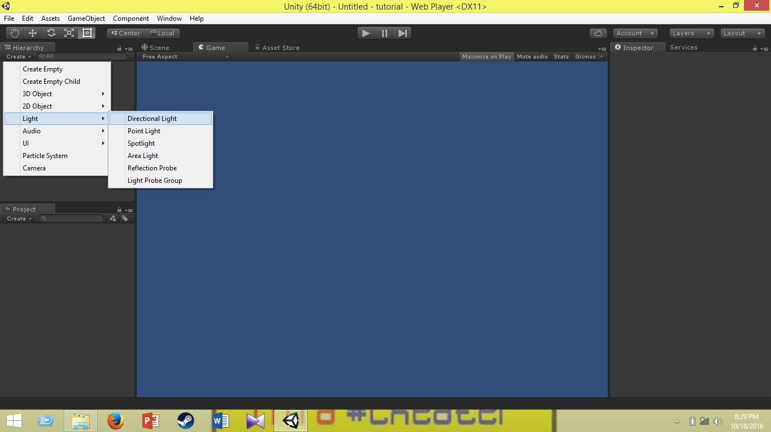

***#Add plane:***

***Create->3D object->plane.***

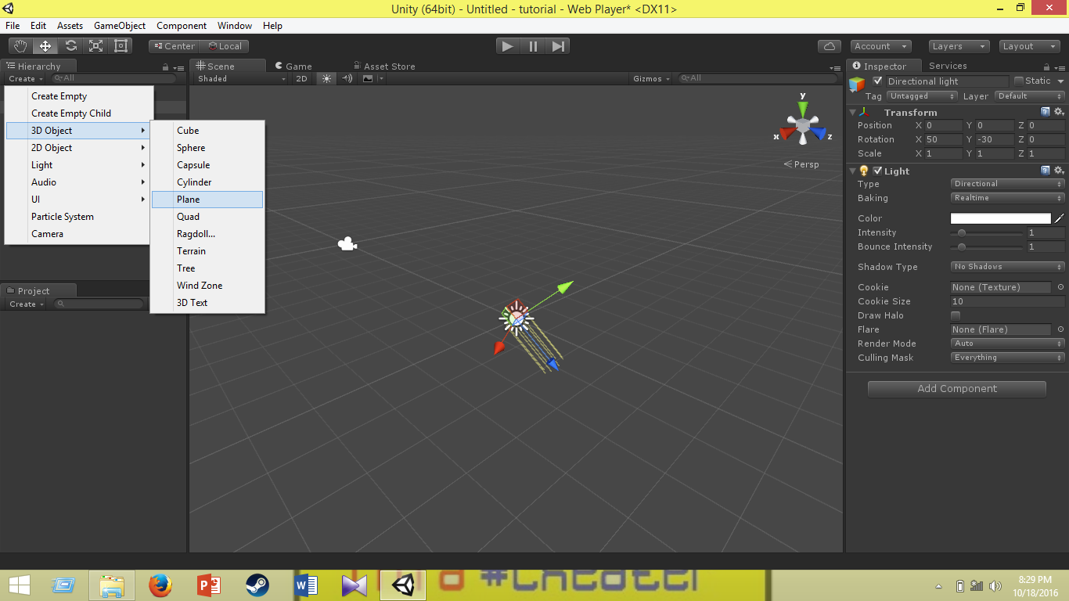

***#Add Goal-post/cylinder:***

***Create->3D object->cylinder.***

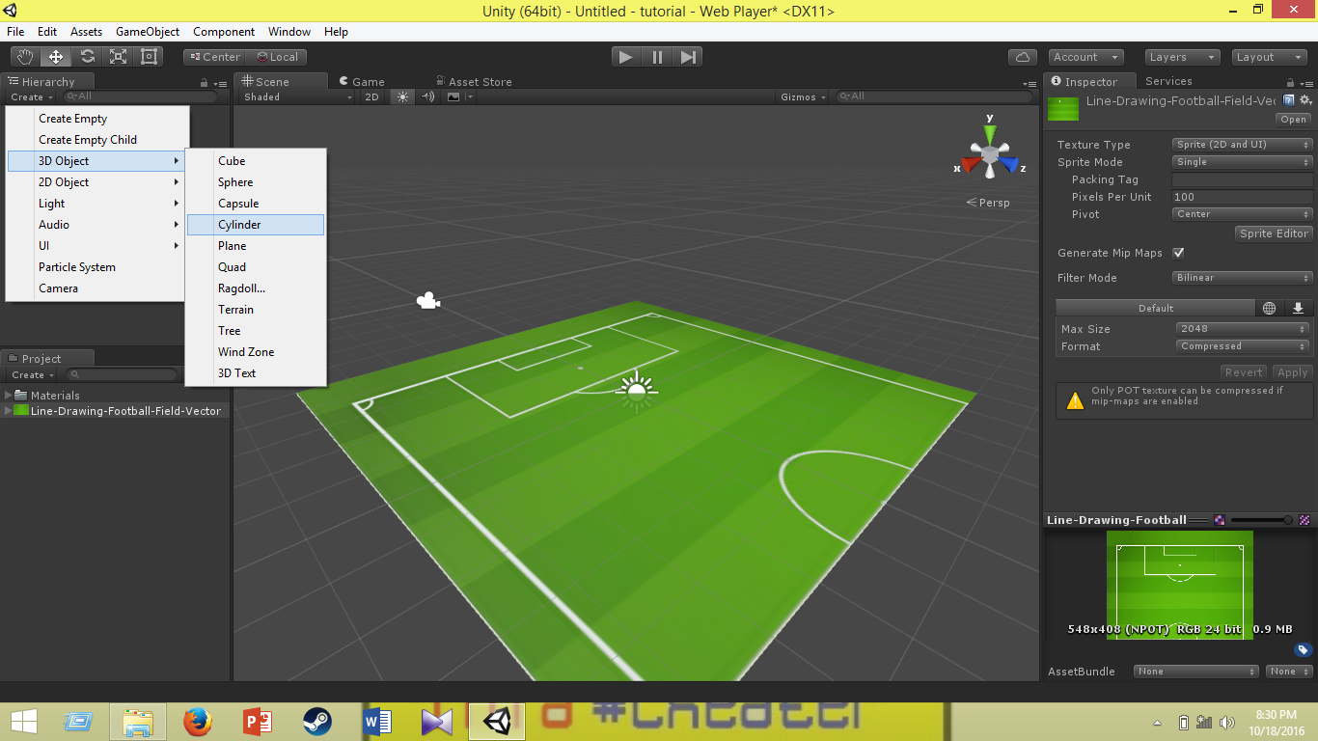

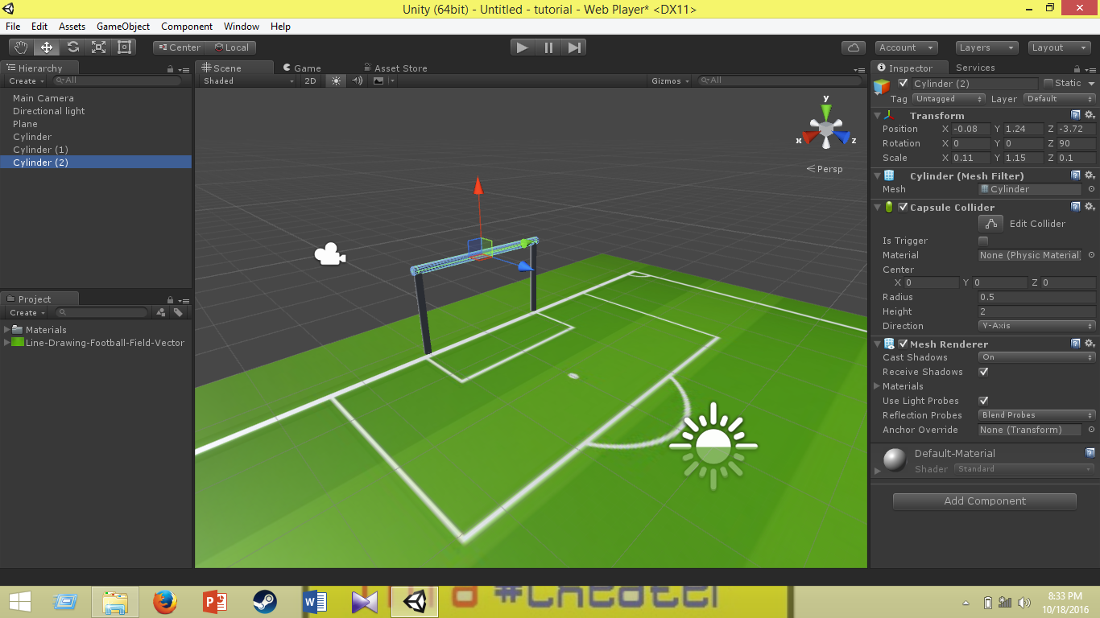

***#Add Ball/Sphere:***

***Create->3D object->sphere.***

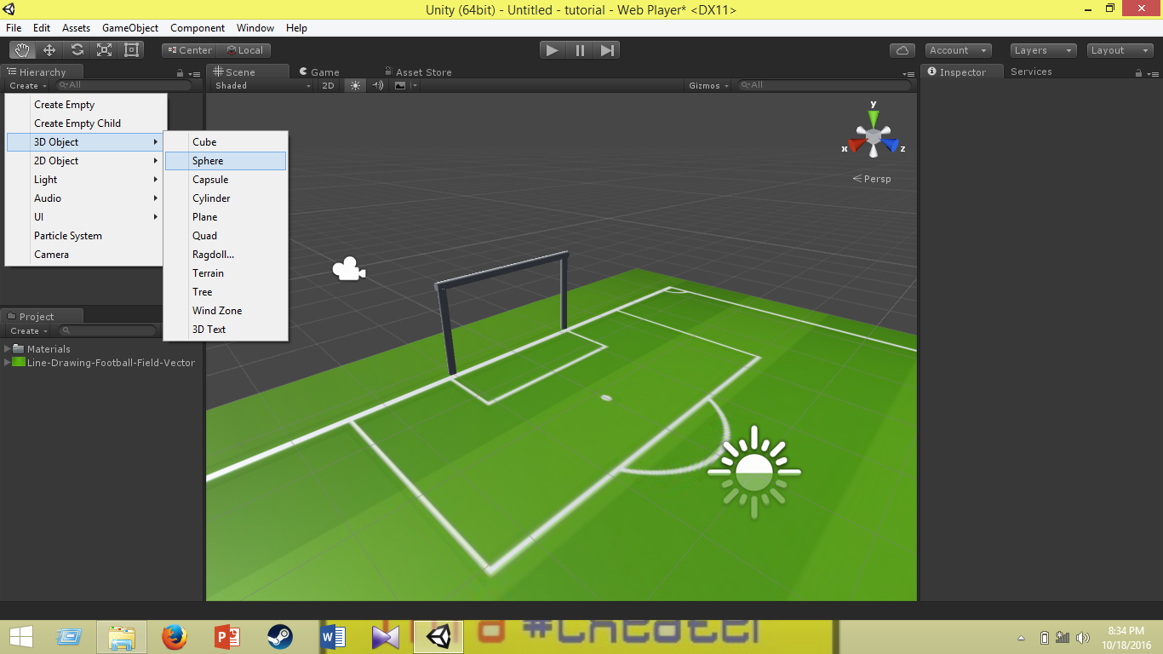

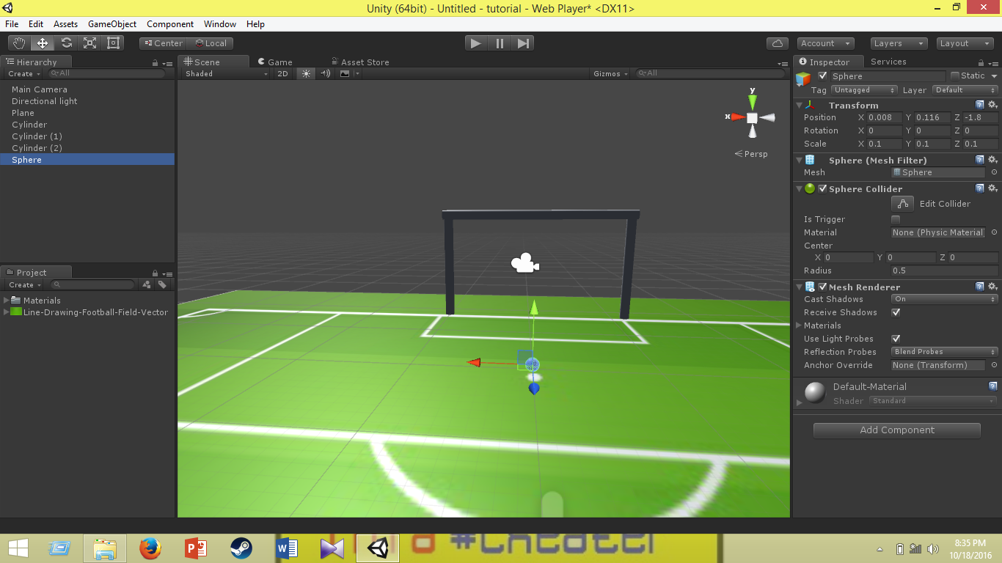

***#Fit Ball Size:***

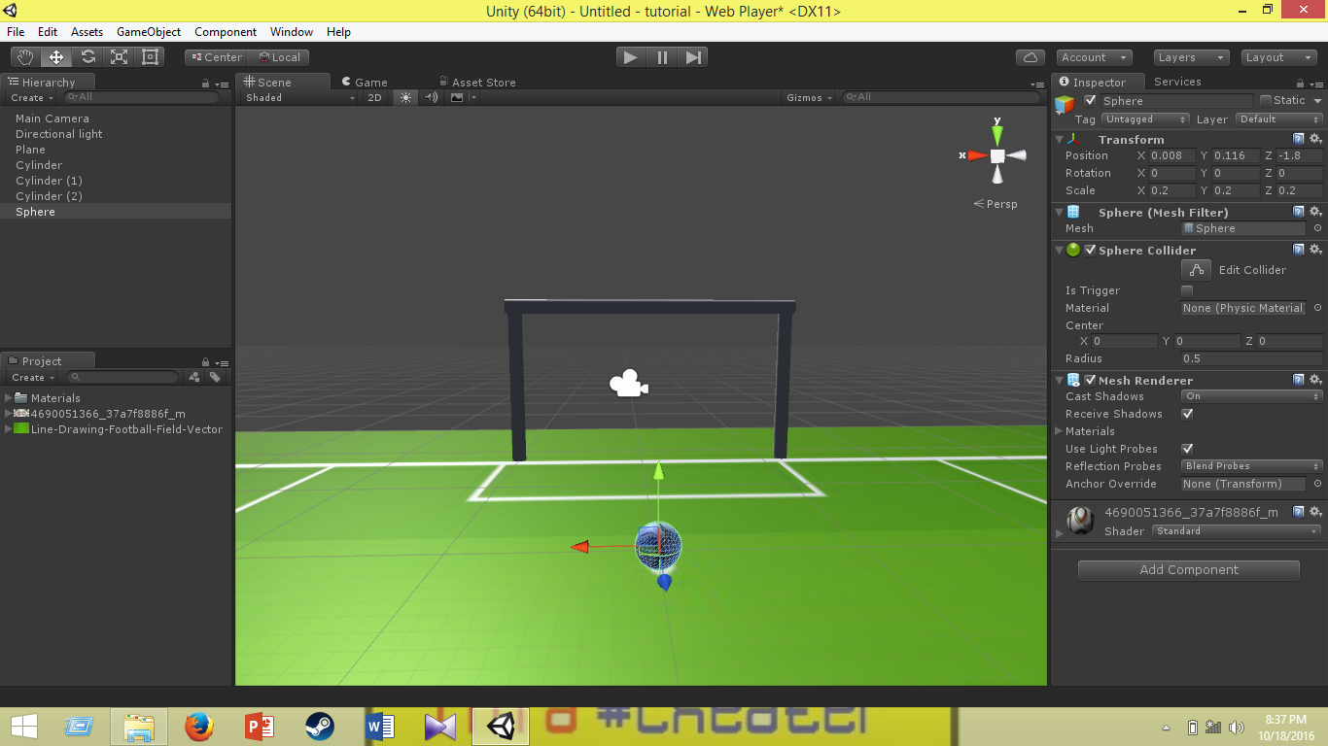

***Necessary program to Move The Ball***

***#Creating Programming Interface :***

***Create(lower one)->C# script.***

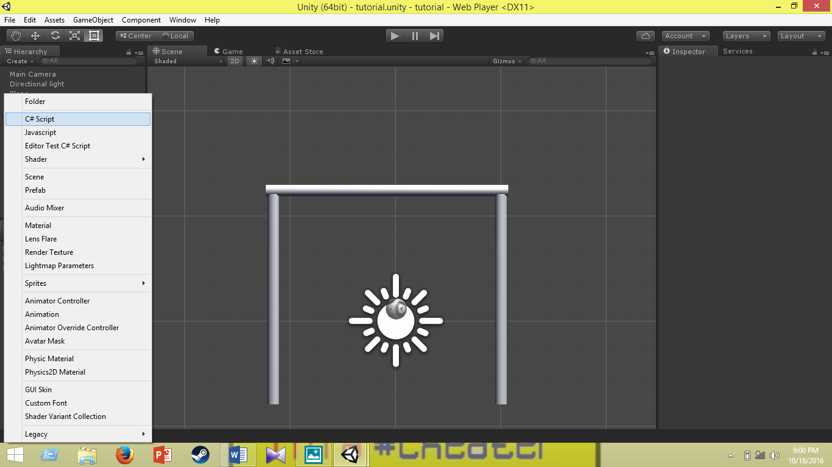

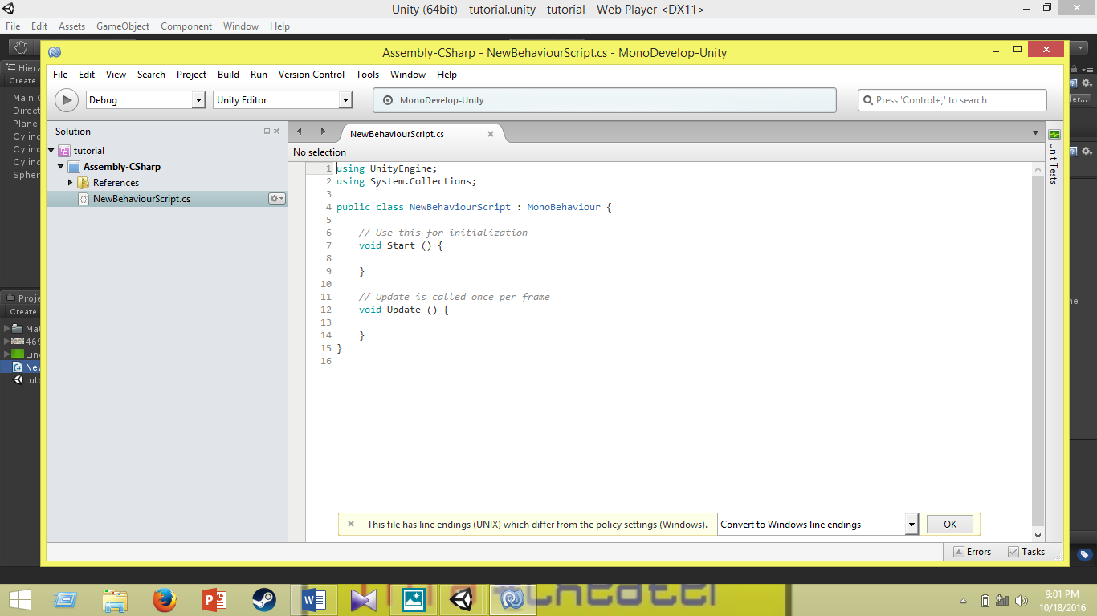

***Game Programming Code***

using UnityEngine;  
using System.Collections; ***//header***  
public class Movement : MonoBehaviour  
{  
    public GameObject ball***; //creating game object***    private int num; ***//number of shot***    private Vector3 origin; ***//ball origin position***  
    private int goal = 0; ***//goal count***    private int point = 0; ***//point count***  
    private float speed = 500; ***//speed of ball***  
    private Rigidbody rb; ***//physics rule***    void Start()  
    {  
     origin = new Vector3 (0.0f, 0.25f, 5.5f);***//starting ball position***  
        rb = GetComponent<Rigidbody> ***();//using physics rule in this scope to control the ball***        num = 0;***//shoot number initialize***  
    }  
    void FixedUpdate ()  
    {  
        float horizontal = Input.GetAxis ("Mouse X");***//horizontal*** input using mouse  
        float vertical = Input.GetAxis ("Mouse Y");");***//vertical input using mouse***  
  
  
        transform.Rotate (-5 * vertical, 2 * horizontal, 0f);***//ball movement direction***  
        if (Input.GetMouseButtonDown (0)) {***//if button clicked***  
            rb.AddForce (transform.forward * speed);***//ball’s movement***  
            speed = 0; ***//after taking shoot***  
            num++; ***//shoot number increase***  
            if (num >= 6) { ***//after taking 5 shot***  
                Destroy (gameObject); ***//game object deleted***  
            }  
        }  
    }  
    void OnTriggerEnter(Collider col)  
    {          
        if (col.gameObject.tag == "Red") ***//if ball hits red***  
        {  
            point += 200; ***//get 200 points***  
        }  
        if (col.gameObject.tag == "Goal") { ***//if goal***  
            goal++; ***//goal count***            point += 100; ***//get 100 point***  
            rb.velocity = Vector3.zero; ***//ball stops***  
            transform.position = origin; ***//ball come to origin***  
            speed = 500; ***//ball gets speed***  
        }  
        if (col.gameObject.tag == "Finish") ***//if ball hits stadium***        {  
            rb.velocity = Vector3.zero; ***//ball stops***  
            transform.position = origin; ***//ball come to origin***   
            speed = 500; ***//ball gets speed again***   
        }  
    }  
          
    void OnGUI() ***//result console***  
    {  
        if (num < 5) { ***//take 5 shoot***  
            GUI.Box (new Rect (10, 10, 150, 60), "SHOOT  " + num + "\nGOAL  " + goal + "\nPOINT  " + point); ***//result console size & contain elements***  
        }  
        else {  
            GUI.Box (new Rect (Screen.width/2-100, Screen.height/2 - 50, 200, 100), "FINAL SCORE"+"\nSHOOT  "+num+"\nGOAL  " + goal+"\nPOINT  " + point); ***//final console containing all results***        }  
    }  
}